Contents

Overview 2

Controls 2

Game Mechanics – Player Characters 3

Game Mechanics – Weapons 4

Weapons 4

Deployables 4

Game Mechanics – Environmental Hazards 6

Game Mechanic – Skill Upgrades 6

Base Skills 6

Buff List 6

Game Mechanic – Pickups 6

AI – Turrets 7

AI – Enemies 7

Objectives – High Score 10

Final Score Board 10

Objectives – Story 10

Map 10

# Overview

Top Down 2.5D

High-score survival

The aim of the game is to survive for as long as possible making use of available resources to survive. Killing enemies will add to a high-score counter. Enemies will swarm and come in 2large numbers compositing of Basic zombie & Z number of specials. Gameplay is fast and hectic.

Primary inspiration is from Boxhead and Solomon’s Boneyard.  
Topdown shooters with emphasis on clearing waves.

See -> Boxhead

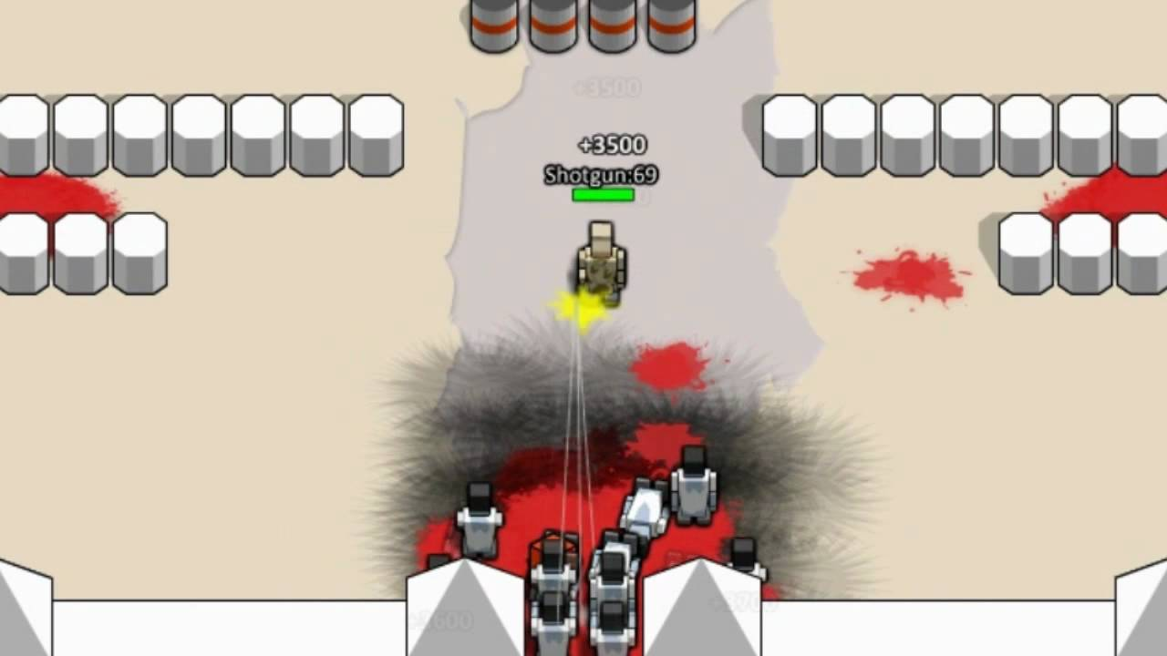

# Story

Sci-Fi. Post-Apocalyptic. Lab.

16:9 resolution

Robot main character.

Scientists created a fighting robot and it is put through trials. The robot’s objective is to survive and escape. As robot fights through waves, it grows w/ capabilities.

In between will have ‘story’ bits.

# Controls

* Movement
  + WASD
* Weapon
  + Q, E to cycle weapons
  + LMB to shoot
  + Mouse to aim
* Special Ability
  + RMB to activate

# Game Mechanics – Player Characters

A few distinct characters to choose from. All have differing stats and unique Special Ability.

Encourages a certain playstyle with each char. Improves replayability.

Health regenerates over time at 1% per 5 seconds. Player movement is fast and responsive.

Stats:

* Health
* Speed
* Ammo Capacity
* Deployable Capacity

|  |  |  |
| --- | --- | --- |
| Class Name & Description | Stats | Special |
| 1) Default  The all-rounder class | All stats 100% | Invulnerability  Duration 5 sec  Cooldown 40 sec |
| 2) Engineer  Focus on Deployables (turrets) | Speed -20%  Ammo Cap -30%  Deploy Cap +50% | Deployable Overdrive  *All deployed weapons +firerate, +damage*  Duration 10 sec  Cooldown 60 sec |
| 3) Buffer / Tanker  High health and focus on buffs | Health +30%  Speed -10%  Deploy Cap -30% | Buff Boost  *Buff duration +100%*  *Buff effect +100%*  Duration 15 sec  Cooldown 40 sec |
| 4) ???  High speed, strafing style | Health -10%  Speed +20% |  |
| 5) RNG Champion  Focus on random chance. Just an idea for fun | All stats 100%  Enemy drop amounts increased by 30%.  On drop following can occur   * Explosion on drop spot * Fire on drop spot * Spawn enemy on drop spot | Roll The Dice  *Drop base chance increased to 50%.*  Duration 10 sec  Cooldown 10 sec |

# Game Mechanics – Weapons

## Weapons

Weapons can fire so long as there is ammo. There is no reloading. There is a cooldown between shots. Bullets have 2 types RayCast

Stats:

* Ammo / Ammo Capacity
* Firerate (Rounds per Min, RPM)
* Damage (Damage per bullet) (based on assumption Basic Enemy is 1 hp)

|  |  |  |
| --- | --- | --- |
| Weapon Name | Stats | Special |
| Pistol  Base | Ammo – infinite  Firerate – 60  Damage – 2 | Infinite ammo |
| Shotgun  Crowd clearing | Ammo – 50  Firerate – 45  Damage – 1 | Spread Shot |
| Machine Gun  Crowd clearing Burst DPS | Ammo – 600  Firerate – 300  Damage – 1 | N/A |
| Sniper  Single target Burst DPS | Ammo – 30  Firerate – 20  Damage – 5 | Penetrating shot. Rounds go through enemies until it hits a wall. |
| Grenade  Crowd Clearing | Ammo – 10  Firerate – 30  Damage – | AOE destruction |
| Turrets can be classified as deployables.  Once deployed it acts as its own entity, own HP, Ammo, etc. The AI will be discussed below in AI – Turrets.  These are just the stats for before they are deployed and in the player’s inventory. | | |
| Turret – Machine Gun | Ammo – | N/A |
| Turret – Rocket Launcher | Ammo – | Targets high health targets |
| Turret – Grenade Launcher | Ammo – | Targets center large groups |

## Deployables

We want the player to have access to addition environmental items that can be used to succeed.

* Turrets (discussed above)
* Barrels
  + Explosion
  + Fire
* Mine
  + Explosion
  + Fire
  + Slowing
  + Stun
* Walls

# Game Mechanics – Environmental Hazards

Player can deploy fire and explosion objects. These can have lingering effects.

Fire damage will take time to burn out and can set ‘Fire’ effect onto entities. ‘Fire’ effect will damage entity over time and spread.

# Game Mechanic – Skill Upgrades

Player will have access to Skill Ups for every N number of enemies killed.

This will provide small increments to base skills or temporary buffs.

## Base Skills

* Health ++  
  + 0.5 hp

## Buff List

* Invulnerability  
  3 sec Invulnerability
* Increased Fire rate
* 0Infinite Ammo

# Game Mechanic – Pickups

Enemies will, on chance, drop ammo boxes on death. Chance to drop goes up with each enemy death that does not drop ammo.

Base chance of 5%, increments by 1% each enemy death.

Pickups will restore a certain ammo type to max cap OR a certain % of cap.

# Game Mechanic – Card Deck (Optional, needs extra art)

The player has access to a deck of cards (max 10 cards) that can add bonuses or “curses” to the current level. Player draws three cards and picks up to three to use in the level.

The cards are divided into three types: bonuses, curses and chance. Bonus cards help the player. Curse cards hinder the player. Chance cards help the player, but have a curse attached to the bonus.

At the end of the level the player can pick one of three cards to add to their deck.

# AI – Turrets

Basic behaviour for turrets:

* Fire on targets when within range
* AI behaviour activates when num of enemies in range >2
* Death on ammo OR hp is zero

|  |  |  |  |
| --- | --- | --- | --- |
| Turret Type | Stats | Specials | AI Behaviour |
| Machine Gun | Ammo –  Firerate –  Damage – |  |  |
| Rocket Launcher | Ammo –  Firerate –  Damage – |  | Targets high health targets |
| Grenade Launcher | Ammo –  Firerate –  Damage – |  | Targets center large groups |

# AI – Enemies

Pathfinding is A-Star or Dikstra (need figure out which to use). Probably use a NavMesh for pathfinding. Make use of FSMs to control AI (idle, stalk, attack, run)

Stats:

* Spawn rate
* Health
* Speed
* Special effects

Under ‘Enemy Type’ is the value of the target. It represents the supposed value of the target to the player in an average scenario where all enemies are present and are equidistant to the player. The feel of priority to kill the target.

Health range:

* Very Low = 1
* Low = 2
* Med = 3
* High = 4
* Very High = 5

|  |  |  |  |
| --- | --- | --- | --- |
| Enemy Type & Concept | Stats | Specials | AI Behaviour |
| Basic  Low target  Swarmer / Cannon Fodder type. Overwhelm with numbers. | Spawn – Very High  Health – Very Low  Speed – Slow | Very high numbers | Move towards player w/ shortest path BUT Uses flocking AI |
| Tank  Medium target  Draw fire from player as the shaking will inhibit their ability to kill effectively | Spawn – Low  Health – High  Speed – Very Slow | Creates shield around itself  Attacks shake player camera, increases in intensity w/ respect with distance from player. | Moves towards players using shortest path.  Attacks at set intervals.  Ignores flocking |
| Shooter – Laser  High target  Player will want to take this enemy out fast as the enemy has the highest player damage in the game. | Spawn – Low  Health – Medium  Speed – Medium | Shoots at player instant raycast | Moves to within a certain range of the player and begins shooting.  When damaged to <50% hp, will run out of range for X number of seconds before returning to normal behaviour |
| Shooter – Projectile (Shooter variant)  Medium target  Make player move around to avoid taking damage / debuff | Spawn – Low  Health – Medium  Speed – Slow | Shoots at player projectile w/ splash.  Splash can be a Damage Over Time (D.O.T.) or debuff (reduced move speed, slower fire rate, blurred vision) | Moves to within a certain range of the player and begins shooting.  When damaged to <50% hp, will run out of range and fire at longer range but slower fire rate |
| Wall Breaker  Medium target  Runs to take out walls. If player is defensive, this will be a High target. | Spawn – Medium  Health – Low  Speed – Fast | Prioritises wall and obstacles and destroys as many before death. | Moves to wall / obstacle closest to itself and destroys it. Repeat till dead. |
| Turret Breaker (wall breaker variant)  Medium target  Runs to take out turrets. If player focuses on turrets or is currently relying on turrets, this will be a High target | Spawn – Medium  Health – Medium  Speed – Fast | Prioritises turrets destroys as many before death. | Moves to turret closest to itself and destroys it. Repeat till dead. |
|  |  |  |  |
| Boss - ???  Will probably need at least 1 boss, probably as a story element. |  | AOE attacks  Large, Slow, Predictable movement / attack pattern |  |

# Objectives – High Score

Each enemy killed has a base score.

Each kill by the player adds a multiplier.

Multiplier decays over time

Score += EnemyScore * Multiplier

## Final Score Board

Will display multiple stats :

* Final Score
* Highest Multiplier
* Num of enemy type Y killed
* Num of bombs used
* Accuracy (shot hit / shot fired)
* Survive time
* etc

# Objectives – Story

Will need some sort of objective based OR additional objects.

Example:

* Pick up key to open door
* Hold out until generator boots up
* Clear area of enemies

Remember, will need downtime between shooting sections else it gets very boring

# Map

Will need BAGD support for this section. Will work closely with ‘Objectives – Story’ to form coherent narrative.

Should have multiple levels with different themes. Lava, Ice, Dessert (yes the edible one), Grass.

Roles

Engine

1. Engine Update -> 6 system update

Main Function (Entry Point)

Opengl

1. Vertex Array Object
2. Vertex Buffer
3. Shader
4. Index Buffer
5. Texture
6. Renderer